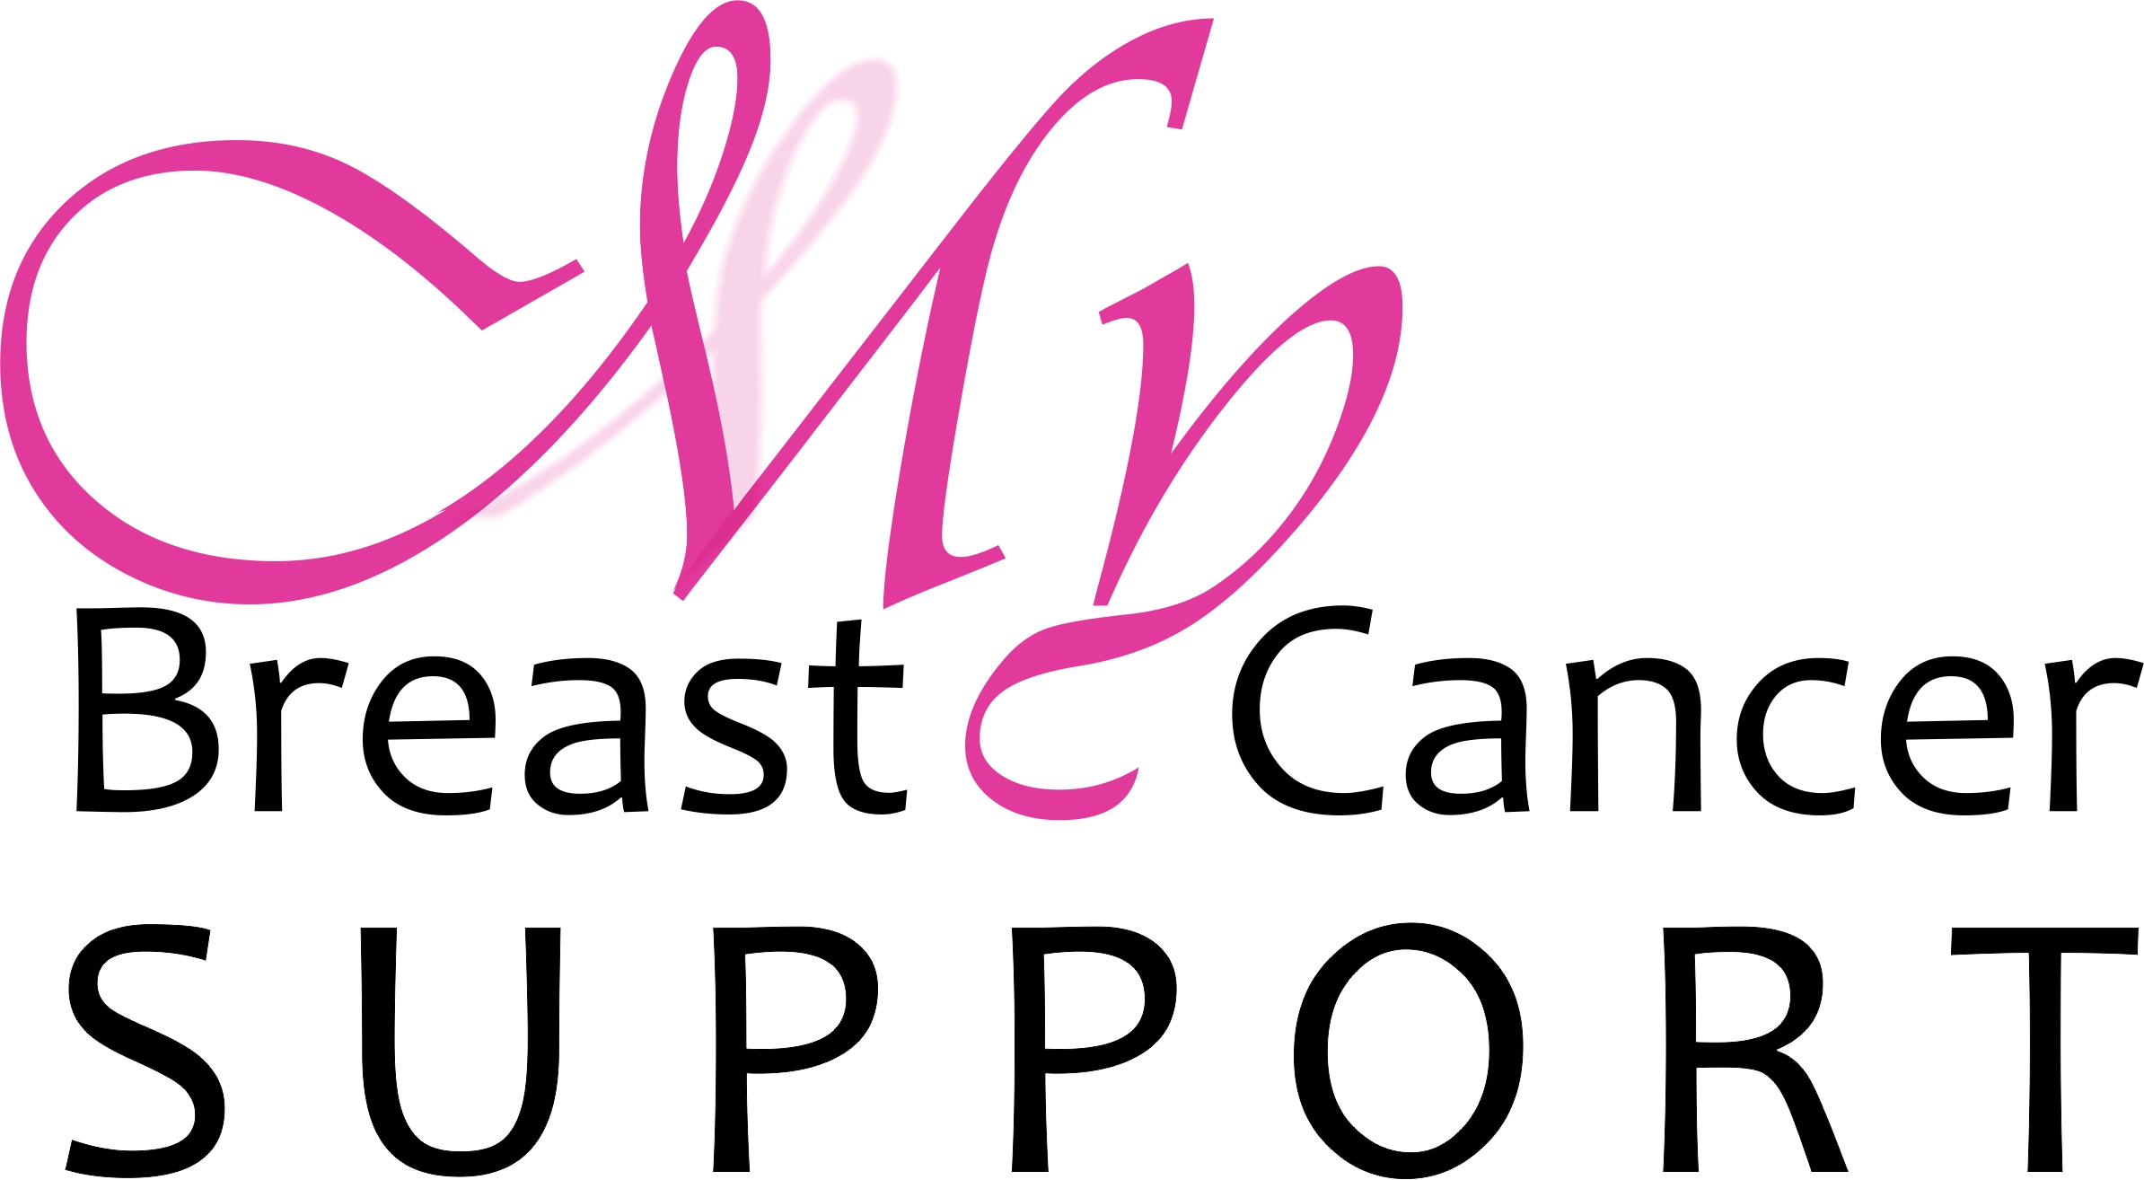
PATIENT ASSISTANCE GRANT APPLICATION 2023

Dear Applicant,

At My Breast Cancer Support, our mission is to provide financial and emotional support to breast cancer patients and their families on the seacoast of New Hampshire and in southern Maine.

Our programs are designed to help a patient take the day-to-day stress out of their lives so they can focus their energy on getting WELL.

Examples of areas where our Patient Assistance Grant program can help include:

- Household needs (groceries, cleaning, yard work, repairs)
- Living expenses (mortgage, rent, home heating fuel, gas, vehicle repairs, utility bills)
- Complementary wellness programs (oncology massage)
- Travel scholarships to breast cancer conferences and retreats

We regret that we are unable to grant the following types of requests:

- Medical treatment/supplies/equipment
- Cash/personal financial assistance
- Legal assistance
- Travel outside the United States

A typical grant will have a value of $50 - $1,750. Please provide us with the following information and we will process your request right away.

We hope this small token of love and compassion will help you along your breast cancer journey!

Warmly,

Jennie

Jennie Halstead
Executive Director & Survivor
My Breast Cancer Support

603.759.5640
jennie@mybreastcancersupport.org

APPLICANT CONTACT INFORMATION

Applicant’s Name:
Address:
City/State/Zip:
Home Phone
Cell Phone
E-Mail Address:
Date of Birth (Must be over 18):
Alternate Contact for grant:
Relationship:
Phone:
Complete Address:
Please let us know how we can help you:

Do you have metastatic disease? Yes No (circle one)

MEDICAL INFORMATION / PERMISSIONS

Treating Hospital:
Physician, Nurse or
Social Worker:
By signing below: I certify that I am the treating physician, nurse or social worker of the Applicant and have deemed it safe and reasonable for this request to be granted.
Signature & Date:

AGREEMENT

1. Granting of a Request.

The My Breast Cancer Support organization (“My BCS”) agrees to review the non-medical grant of the person named above (“Patient”) in accordance with the terms and conditions of this Agreement. My BCS reserves the right in its sole discretion to decide if a request shall be granted.

2. Eligibility.

The services MY BCS provides are available to patients who are actively being treated at Portsmouth Regional Hospital, Wentworth Douglass Hospital, Exeter Hospital, York Hospital, the Cancer Care Center of York County, Frisbie Memorial Hospital, New England Cancer Specialists and Southern Maine Health Care and who match the attending hospital’s eligibility considerations. Residents of the Seacoast of New Hampshire and Southern Maine who are being treated at other facilities are eligible as well.

Services are available to those patients who show a need when going through treatment. Requests for MY BCS services will come directly from the oncology staff at the above facilities and will be reviewed and screened by that staff for financial considerations. Should a request for assistance be directed to MY BCS outside of the attending oncology center, MY BCS will bring it to the attention of the treating hospital / oncology center for the appropriate approvals.

At this time, we are only able to offer these programs to patients in active treatment as opposed to those who are in the maintenance / follow-up stage of treatment.

3. Permission to disclose medical condition.

The Patient grants MY BCS the right to disclose the nature of his/her medical condition to the extent necessary in the fulfillment of the grant request. Furthermore, the Patient grants My BCS permission to obtain general medical information about the Patient which My BCS may feel necessary for fulfillment of the non-medical grant request and authorizes all physicians and medical care providers to provide MY BCS with this information.

4. Relatives/Friends.

Should the grant request include travel / accommodations, no person may accompany the Patient during getaway unless specifically agreed to in writing between My BCS and the grant recipient.

5. Waiver.

The Patient and all participants hereby waive all rights he or she may have or may hereafter acquire against My BCS, its officers, directors, agents, and employees arising out of any injury, damages, or losses suffered by the Patient, and all participants, arising out of or in any way related to My BCS preparation, execution or fulfillment of the grant, regardless of whether such loss or harm is caused by the active, passive or gross negligence of My BCS or any other person.

6. Release.

Patient, and all participants, together, and each of them individually, does hereby forever release and remise My BCS, its officers, directors, agents, and employees from any and all claims, lawsuits, damages, or losses arising out of or in any way related to My BCS preparation, execution or fulfillment of the grant, any injury, damages, or losses suffered by Patient or participants, or any of them of whatever nature, and of whatever extent, regardless of whether such loss or damage is caused by the active, passive or gross negligence of My BCS or any other person.

7. Indemnity.

Patient, and all participants, together and each of them individually, hereby agree to indemnify and hold harmless My BCS, its officers, directors, agents, and employees of and from any and all losses suffered by My BCS, its officers, directors, agents, and employees as the result of any claim, lawsuit, or action arising out of or relating in any manner to My BCS’ preparation, execution and fulfillment of the grant, or to breach by Patient, and all participants of the representations and warranties contained in paragraph 6 of this agreement. Said hold harmless and indemnity includes, but is not limited to, reasonable attorney’s fees and costs incurred by My BCS, it officers, directors, agents, and employees in retaining attorneys of My BCS’ choice to defend all such claims, lawsuits, and actions.

8. Grant expenses.

The grant amounts My BCS has agreed to pay is set in advance and directly related to the fulfillment of the grant. The grant recipient, relatives or friends together understand that they may incur additional expenses as a result of unforeseen circumstances beyond My BCS’ control, especially if fulfillment of the grant involves travel. My BCS shall not have any responsibility or liability for additional expenses incurred by Patient, relatives or friends which have not been expressly assumed by My BCS pursuant to this Grant Agreement.

SIGNATURE of APPLICANT

By signing (or initialing if filling this out electronically) below, you affirm and acknowledge that you have read this Agreement, have retained a copy, and fully understand its provisions.

__________________________ __________________________________________ ________________
Patient Name (printed) Patient Signature (or initials) Date

Please email or mail completed application to:

My Breast Cancer Support
PO Box 1576
Portsmouth, NH 03802-1576
info@mybreastcancersupport.org
603-759-5640

FOLLOWING UP
We would like to check in with you in a few weeks to see how our program is helping you.

Please initial to the right if we have your permission to contact you and put a check mark next to your preferred method. | Phone Email

PUBLICITY PERMISSIONS
Occasionally we share general information about the people we help to existing and potential donors. In all cases we only mention a patient’s first name and/or treating hospital and/or item or service donated.

Please initial to the right if we have your permission to include you on this list.

